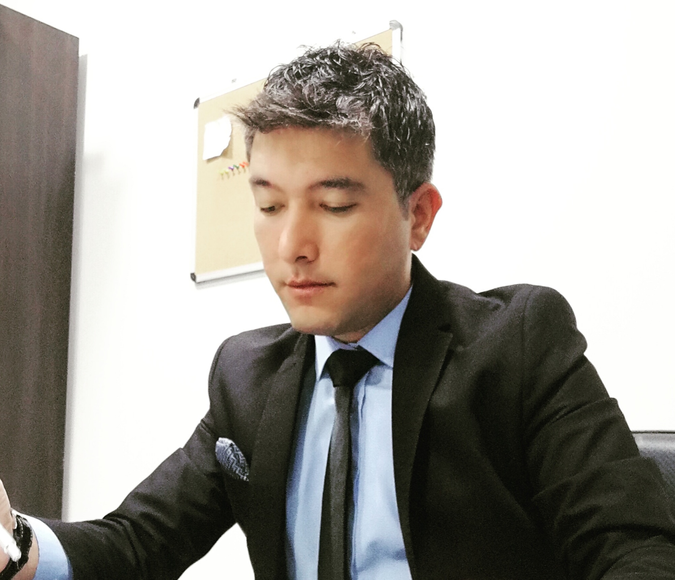
SERHAT SUCU

PERSONAL INFORMATION
Phone : +90530 765 89 14
E – Mail : serhat_sucu_01@hotmail.com
Date of Birth : 20/09/1988
Address : Adana / TURKEY
Military Service : Completed (02/08/2015)

WORK EXPERIENCE
05/2018 – 08/2018 Jrw Welmond Luxury Hotel & Casino , Batumi,Georgia
Night Manager
- Direct and oversee all Hotel & Casino operations during the night to ensure guest satisfaction and safety
- Act as manager on duty for the hotel&casino during the absence of the General Manager. dealing with complaints, problem solving, disturbances, special requests and any other issues that may arise
- Manage the night shift in the departments, ensuring all employees perform the tasks assigned to them and coordinate Front Office activities with other departments

04/2017 – 5/2018 Kaya Artemis Resort & Casino Cyprus (740 rooms)
Front Office Supervisor
- Assist the Front Office Manager in the daily running of the front office operations and acting as a FOM in his absence
- Manages and motivates the Front Office team in order to provide a high standard of service for customers.
- Provide high level of customer service and maintain a high profile in the day to day front office operations.
- Have a good knowledge of all systems and standard operating procedures of front office.

11/2016 – 2/2017 Hilton Garden Inn Safranbolu(Pre-opening)
Assistant Front Office Manager / Duty Manager

- manage and monitor activities of all employees in the Front Office department making sure they adhere the standards of excellence and to the guidelines set in the employee handbook, hotel policies and procedures, coaching, training and correcting where needed.
- Undertake full responsibility for Scheduling and Payroll of the department.
- Inform all Front Office staff of daily activities, group and VIP arrivals as well as special requests and repeat guests. Check accommodations, making sure any special requests are carried out accordingly, greet guests upon arrival and ensure escort to accommodations if appropriate.
- Dealing with complaints, problem solving, disturbances, special requests and any other issues that may arise as a Duty Manager
- Supervise associates in their assigned job duties.Assist in hiring and training front office staff.
- Assist to set Front Office Budget, monitor Profit & Loss and cash handling throughout the year. Supervise Upsell program at the Front Office and work as part of the Yield Management team to try and maximize revenue for the hotel

03/2016 – 10/2016 Hilton Dalaman Sarigerme Resort & Spa – MUGLA (Seasonal)
Night Auditor & Shift Leader (410 rooms)

- Prepare and run front office night audit reports and statistics and distribute to the different hotel departments as required when covering night shifts
- Ensuring all guest arrival and departure procedures are completed as defined in the Hilton standards step-by-step
- Act as Manager on duty for the hotel in the absence of Night Manager
- Manage and review Morning brief sheet that showing VIP daily arrival & departure ,occupancy and revenue.
- Reconcile revenue, cash drops, credit card and micros reports.
- Set up and maintain a high level of personal service and guest recognition, with particular attention to VIP's and amenities.

09/2015 – 02/2016 Doubletree By Hilton Cappadocia – NEVSEHİR
Reservations&Group Executive

- Receive and process telephone,faxes and e-mailed reservations accurately in to the system
- Follow up all group enquires,contracts,update group and individual guest profiles
- Prepare weekly production and occupancy forecast report and supply to management department concern.
- Determine the most appropriate room type to meet guest requirements and maximize room rate. follow up online booking channels such as booking.com ,expedia
- Responding and following on RFPs (Request for proposal)

12/2013 – 01/2015 Westgate Smoky Mountain Resort & Spa – Gatlinburg,TN (USA)
Management Training
Front Desk Supervisor - (765 rooms)

- Administer all reservations,cancellations and no-shows,in line with company policy
- Compliting procedures when guests arrive and leave
- Assist and observe front Office employees that their duties are carried out efficently
- Respond to customer needs and requests in a timely manner
- prepare operational and financial records for Manager to review.
- inform all Front Office staff of daily activities, group and VIP arrivals as well as special requests and repeat guests. Check accommodations, making sure any special requests are carried out accordingly, greet guests upon arrival and ensure escort to accommodations if appropriate

06/2013 – 11/2013 Club Magic Life Sarigerme Imperial – MUGLA(Seasonal)
Night Auditor

- Greating guests,answering phones,organizing and verifying receipts
- Posting accounts,running and distributing daily reports,check-in and check-out process
- Undertake overnight responsibility for reception, checking guests in and out, taking reservations and dealing with all telephone enquiries

05/2012 – 10/2012 Moose Creek Cabins & Inn – West Yellowstone,MT (USA)
Receptionist
- Answering all phone enquiries including phone& face to face reservations
- Deal with all enquiries in a professional and courteous manner, in person, on the telephone or via e-mail

06/2011 – 09/2011 Fairfield Inn & Suites By Marriot Hotel – Rapid City,SD (USA)
Housekeeper
05/2010 – 08/2010 Hilton Hotel – ADANA
Traniee (Kitchen)
06/2009 – 10/2009 Ruya Hotel – MUGLA
Waiter/Bartender
EDUCATION & CERTIFICATES
University Mersin University - MERSİN
Faculty of Tourism - 09/2007 – 06/2013
01/2015 Hospitality Supervisor Certificate – American Hospitality Academy (USA)
Supervisor Certification Course
01/2015 Westgate Resort (USA)
10 Months Training Internship program
09/2015 ONQ Hilton Worldwide University
Online ONQ course
02/2012 Ticketing Certificate – Turkish Airlines
Passenger fares and ticketing course
COMPUTER SKILLS
Mc office,Windows operating system
ONQ,R&I,Fidelio,Elektra,Opera,Mod,Sedna
LANGUAGE SKILLS
English Reading: Advanced, Writing: Advanced, Speaking: Advanced
German Reading: Good, Writing: Good, Speaking: Good

Taner Yildiz - Senior Manager – Suites and Focused Service Brand Management Europe, Middle East & Africa at Hilton 0532 701 89 10
Cenk Alkocoglu – Front Office Manager (Limak Cyprus Deluxe)
0533 826 88 72
Mustafa Kirman – Front Office Manager (Hilton Garden Inn Safranbolu)
0535 208 69 52
Serdar Soltekin – Front Office Manager (Hilton Dalaman Resort & Spa)
0530 884 50 18
Darlenee Keech – Front Office Manager (Westgate Smoky Mountain Resort & Spa
+1 865-430-4800
Brenna Mauer – General Manager (Moose Creek Cabins&Inn)
+1 406-646-7952
Prof.Dr Kemal Birdir – Mersin Universitesi Turizm Fakultesi Dekanı
0532 486 1889
Cris Walker – General Manager (Fairfield Inn&Suites By Marriot)
+1 605-854-1172

